CellSol ESP32 Pocket Pylon Setup Guide

What You Will Need

- A Heltec Lora32 or Lora32v2 module
- The Arduino software, available here: https://www.arduino.cc/en/Main/Software
- A USB cable
- Our CellSol ESP32 Pocket Pylon firmware, available on this GitHub repository
- A battery for the Lora32
- A solar panel to charge the battery (optional, USB may also be used for charging)

Step 1: Setting Up the Arduino Software

To program your Lora32, you will need to have the board manager in the arduino software configured to support it. You will also need to install several arduino libraries used by our firmware.

You will need to add a URL to the Board Manager before starting. In the Arduino software, navigate to File -> Preferences... and in the dialog box, click the browse icon next to “Additional Board Manager URLs”. In the text box that opens, add a new line, and enter the following URL:
https://dl.espressif.com/dl/package_esp32_index.json
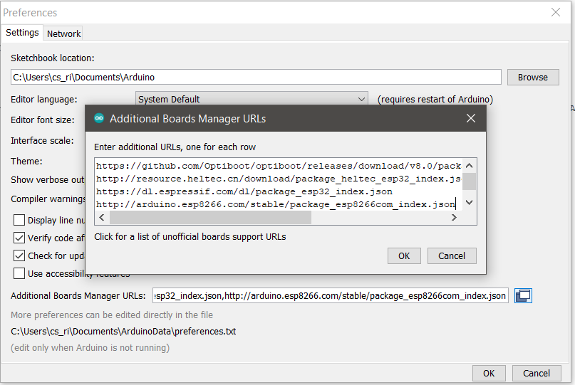Figure 1: Board Manager URLs After Adding

Once this URL is added, you can go on and add the Lora32 boards using the Board Manager.
Navigate to Tools -> Board -> Boards Manager...
Enter “Heltec” in the search, and “Heltec ESP32 Series Dev-Boards” should appear. Click “Install” at the bottom right. Once installed, this button will be replaced by “Remove”.
With the boards configured, it is on to configuring the libraries. Navigate to Tools -> Manage Libraries...
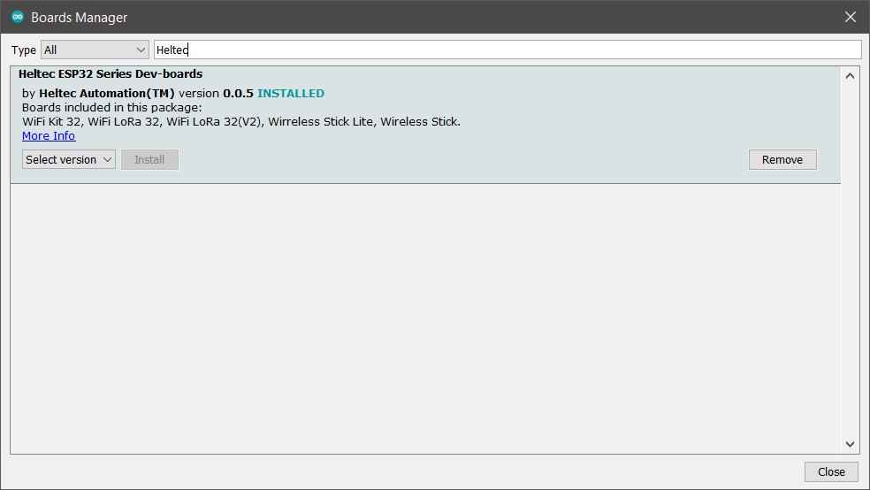Figure 2: Board Manager After Installing Heltec ESP32
A window similar to the Board Manager will open.
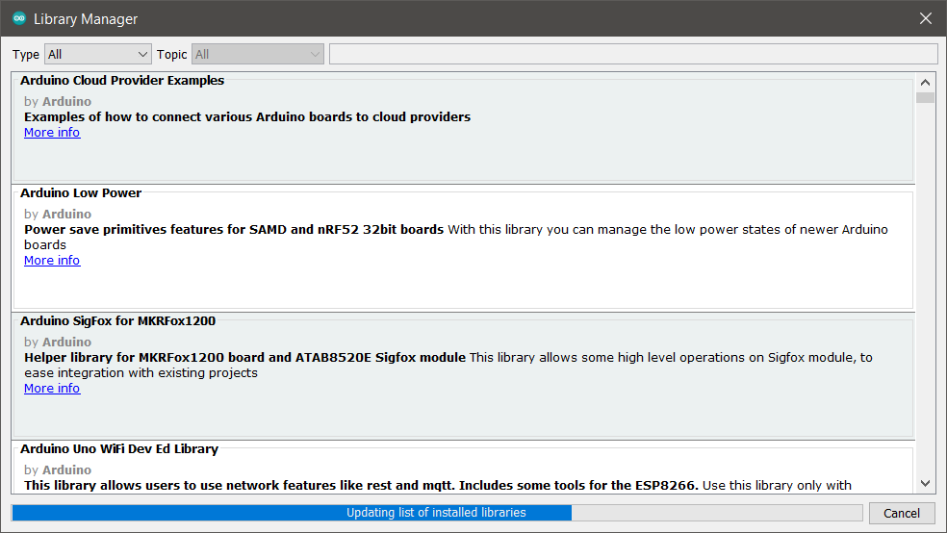Figure 3: Arduino Library Manager

You will need to search for the following libraries, and, just like installing the boards in Board Manager, install them:
- Adafruit BusIO
- Adafruit GFX Library
- Adafruit SSD1306
- Heltec ESP32 Dev-Boards
- LoRa (by Sandeep Mistry)
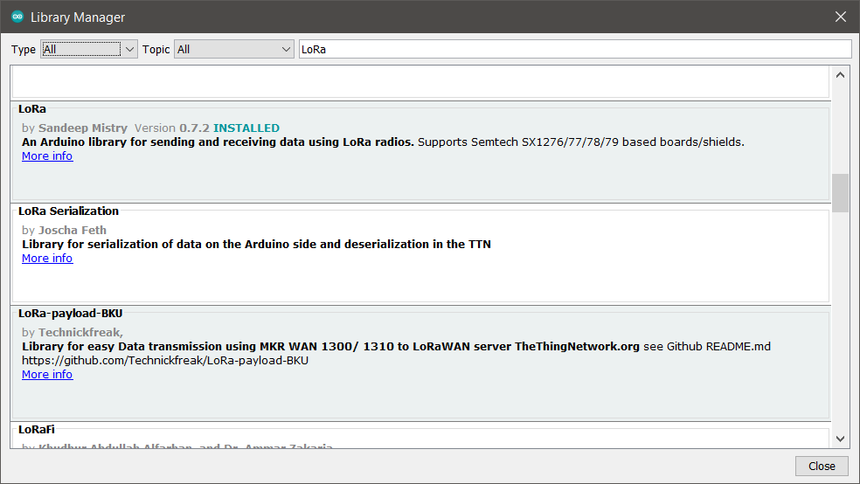Figure 4: Library Manager Showing LoRa Library to Install
Step 2: Setting Up the Lora32 for Programming
With the Lora32 unplugged from your computer, navigate to Tools -> Port and look at the serial ports listed there.
Now, plug in your Lora32 using the USB cable. Your operating system should automatically detect it as a serial port, and configure that port. Navigate again to Tools -> Port. A new one should have appeared: this will be the serial port for the Lora32 you just plugged in. Click on it to select it for programming.
You also need to tell the arduino software that it is using a Lora32 or 32V2. Do this by again navigating to Tools -> Board -> Heltec ESP32 Arduino and selecting Lora32 (black board) or Lora32V2 (white board) depending on which one you are using.

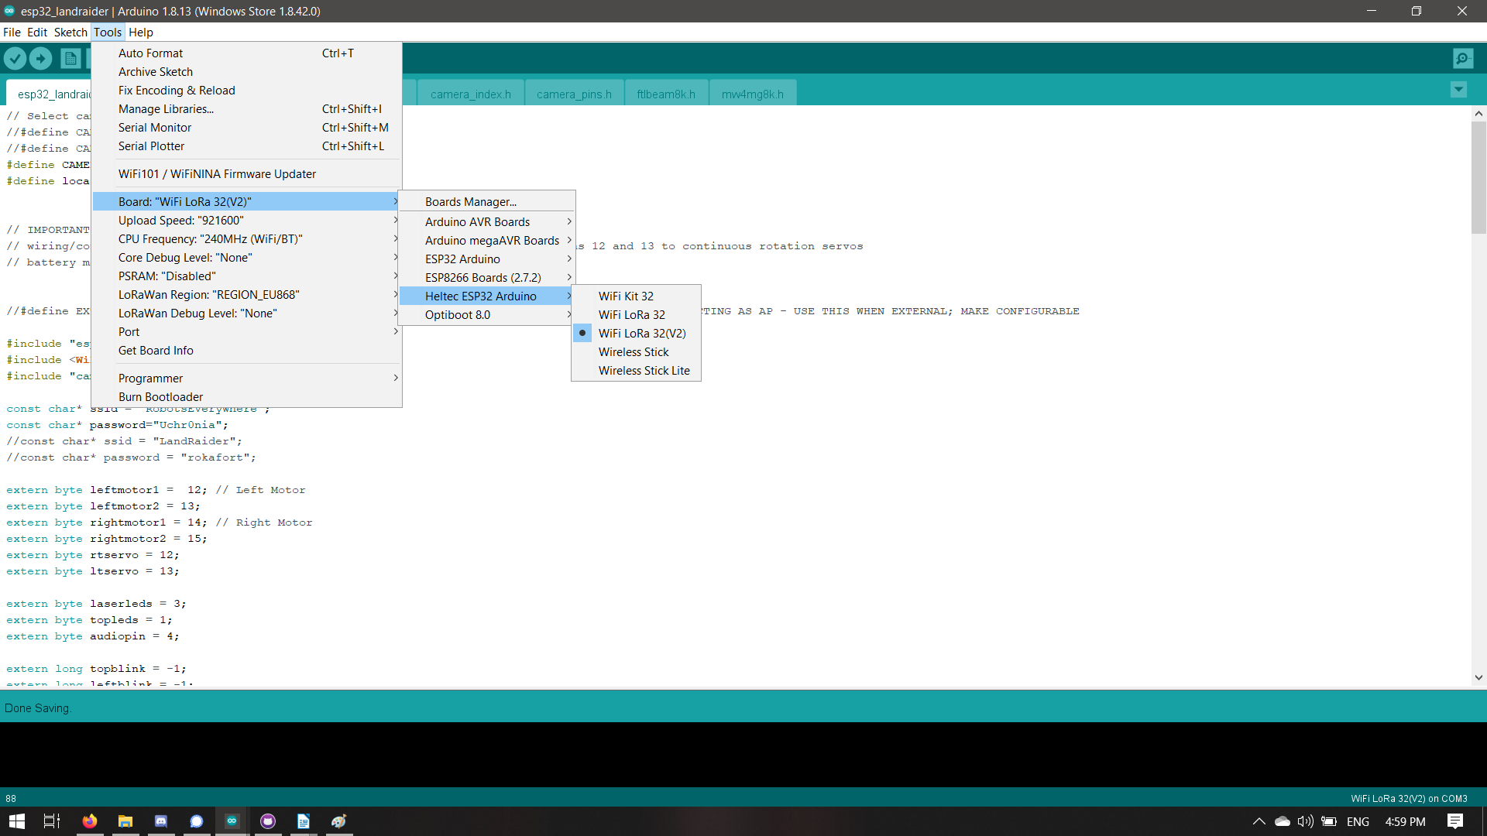Figure 5: Selecting the Lora32 Board
The other settings for the Lora32 board can be left default; even if you are not in the EU, the REGION setting is not used by the firmware.
Step 3: Configuring the Firmware
There are several firmware settings you will need to choose in order to get the performance you want out of your pocket pylons.
If you have not already done so, open the firmware’s arduino project by File -> open, or using your system’s file manager, and opening “esp32_wifi_bt.ino” that you downloaded at the beginning.
All of these options are configured in #define lines at the top of the root file “esp32_wifi_bt.ino”
Most of these options are turned on and off by commenting (making the line begin with //) or uncommenting (removing the //) the #define statements. The options you must set to make your pocket pylon work are explained below. The options not described are intended for developers, for more advanced configuration – you don’t have to worry about them right now.
Option Name | Purpose | Allowed Values
WIFI_IS_CLIENT | Activates wifi gateway mode if uncommented. This connects the CellSol network to a wifi router. | None
WIFI_IS_HYBRID | Activates wifi hybrid mode if uncommented (gateway + AP). Takes priority over WIFI_IS_CLIENT. | None
DHCP | Uses DHCP for connecting to an upstream router (gateway or hybrid mode) if uncommented | None
REPEATER_ONLY | Emulates the Arduino repeater, turning off the wifi features entirely, if uncommented. Takes priority over everything. | None
CLIENT_IP_ADDR | Client IP address, with the numbers separated by commas; only used in IS_CLIENT or IS_HYBRID and only if DHCP is off. | An IP address separated by commas such as 192,168,1,55
GATEWAY_IP_ADDR | IP address of the gateway router, with the numbers separated by commas; only used in IS_CLIENT or IS_HYBRID and only if DCHP is off. | An IP address separated by commas such as 192,168,1,1
GATEWAY_SUBNET | Subnet mask for the gateway router, with the numbers separated by commas; only used in IS_CLIENT or IS_HYBRID and only if DCHP is off. | An IP subnet mask separated by commas such as 255,255,255,0
WIFI_UPSTREAM_AP | The access point name to be connected to if in IS_CLIENT or IS_HYBRID mode. | Network name in double quotes, like “RobotsEverywhere_24”
WIFI_UPSTREAM_PWD | The password to the access point to connect to in client or hybrid mode | Password in double quotes, like “derpderp”

More about the 3 modes. // TODO: add some little explainer graphics here?
// TODO: explain “Switch every minute” mode.
Access Point Mode: This mode makes the pylon into a WiFi access point. To access the web chat interface, you can connect to that access point with any device.
Client Mode, also known as Gateway Mode: this mode makes the pylon connect to an outside wifi network. You can then access the web chat interface from any computer on that network, as long as you know the pylon’s IP address.
Hybrid Mode: this is just the combination of both Gateway Mode and Access Point Mode. The node will not be as responsive, but it will do both.
Step 4: Programming Your Pylon
Once the firmware is configured, programming the pylon is simple: simply press Ctrl+U or navigate to Sketch -> Upload.
This should begin an upload process that shows at the bottom of the screen. At the bottom right, “done uploading” will display when it is finished, and your pylon is ready to go.

Step 5: Testing Your Pylon
With the pylon still connected to your PC, it should be powered by the USB port. The display should be on, showing the pylon’s IP address.
Using the PC, or a mobile phone or other device, first connect to the network the pylon is on. If it is in client mode, it will be on your WiFi network. If it is in AP mode, connect to the AP it is providing. Next, open a web browser, and type the IP address of the pylon (it will show up on the ESP32’s OLEd display screen) and press enter. This should show you the pylon’s web interface.
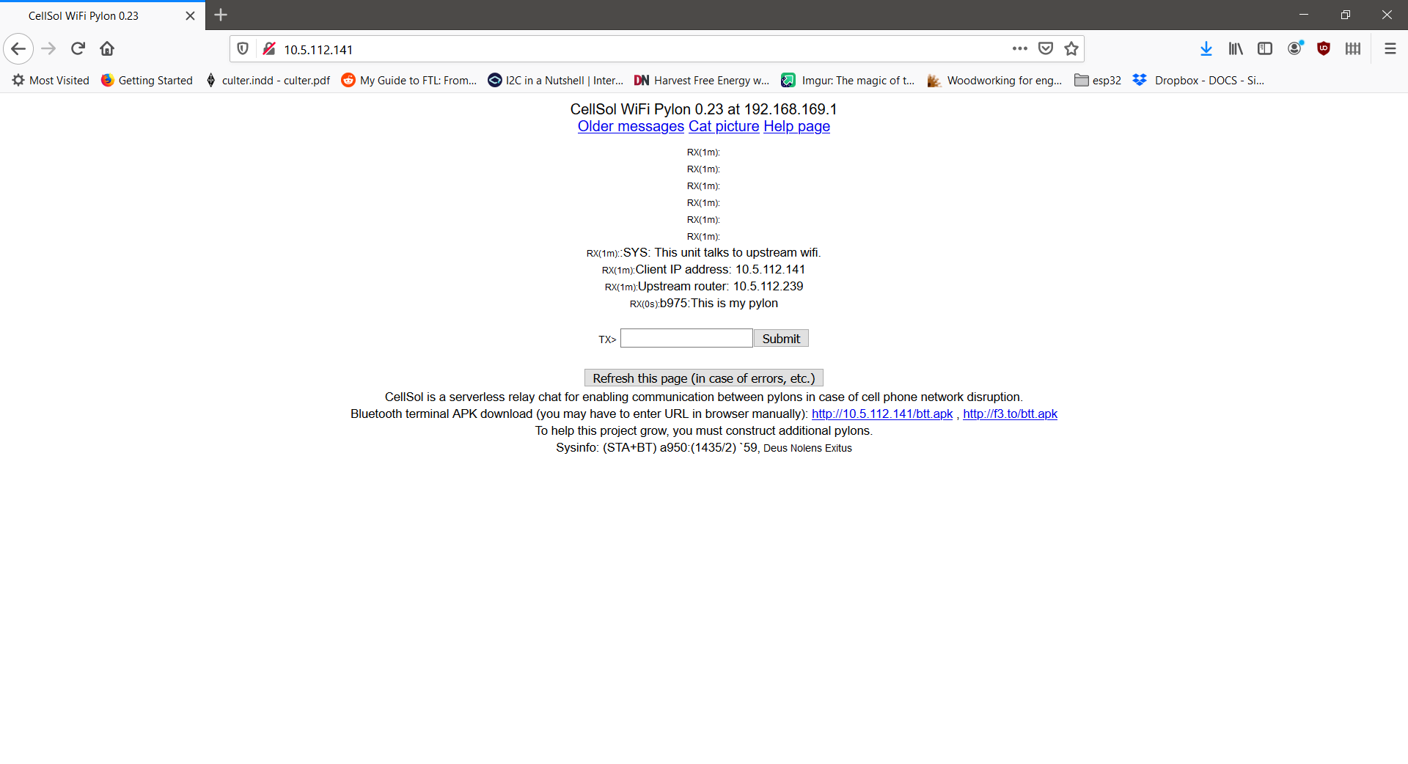Figure 6: A fresh pylon, viewed through the web interface
With this working, you are ready to assemble your pylon.
Step 6: Assembling your Pylon
// TODO: visual guide to putting the Lora32 in the waterproof case and attaching the antenna

